Chapter 10, Problem 8.

Use nodal analysis to find current i_{o} in the circuit of Fig. 10.57. Let i_{s} = 6 cos(200t + 15°) A.

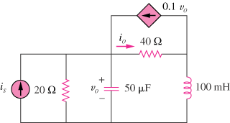

Figure 10.57
For Prob. 10.8.

